# Pacific Australia Labour Mobility (PALM) Scheme quarterly update

# Data current up to 30 September 2024

# Published: 27 November 2024

## Key findings

PALM scheme worker counts are a measure of the number of workers from participating PALM scheme countries holding a valid visa who are currently onshore in Australia. PALM scheme worker numbers are affected by seasonal patterns, for example the nature of work in agriculture or workers returning home for holidays. Worker participation will vary from month to month.

During the COVID-19 pandemic, the PALM scheme was heavily relied upon (through the   
COVID-19 Pandemic event (subclass 408 visa) as there were limited alternate sources of temporary labour. Growth rates in the PALM scheme have moderated as the subclass 408 visa concludes. In April 2022, 21% of PALM scheme workers were subclass 408 visa holders, compared with under 1% of PALM scheme workers in September 2024. The subclass 408 visa primarily supported short–term workers Agriculture.

Over the 12 months to September 2024:

* the worker count decreased by 10%
  + short-term worker counts declined by 25% over the year
  + long-term worker counts increased by 7% over the year.
* By industry, Agriculture declined over the year (down 23%), largely attributed to the decline of 408 visa holders. Most other industries saw an increase: Meat processing (up 4%), Accommodation up 15%, Health care and social assistance increased by 43% and Other industries rose significantly, by over 400% (from 105 workers in September 2023 to 590 in September 2024).
* By country, between September 2023 and September 2024:
  + worker counts increased for: Kiribati, Nauru, Papua New Guinea, Timor-Leste and Tuvalu
  + worker counts decreased for: Fiji, Samoa, Solomon Islands, Tonga, and Vanuatu.

The number of PALM scheme employers has continued to grow since the new PALM scheme deed and guidelines were introduced in July 2023.

* 93 new employers have joined the scheme since July 2023, bringing the total number of employers to 485 in September 2024, a record high since the commencement of the PALM scheme (and predecessor schemes).

There are a range of factors which impact demand for PALM scheme workers, including:

* climate change, natural disasters and local severe weather events impacting harvest yield and timing
* drops in some global commodity prices
* the number of Working Holiday Makers returning to almost pre-COVID levels in June 2023, with continued growth in the second half of 2023 (over 171,000 as at the end of August 2024)
* seasonality of some agricultural commodities.

## PALM scheme worker trends

#### 

In September 2024, there were:

* 31,230 workers
* 14,360 in the short-term stream
* 16,870 in the long-term stream

There have been shifts in composition over time, with significant growth in the long-term stream which more than doubled, from 7,010 workers in April 2022 to 16,870 workers in September 2024 (an increase of 141%).

The short-term stream has been generally declining since April 2022, prior to the commencement of the new PALM scheme in mid-2023. Since April 2022, the short-term stream has declined by 25%.

**PALM scheme employer trends, July 2023 to June 2024**

In September 2024, there were:

* 485 employers
* 387 were direct employers  
  (Up 2% in the 12 months to September 2024)
* 98 were labour hire employers  
  (Up 3% in the 12 months to September 2024)

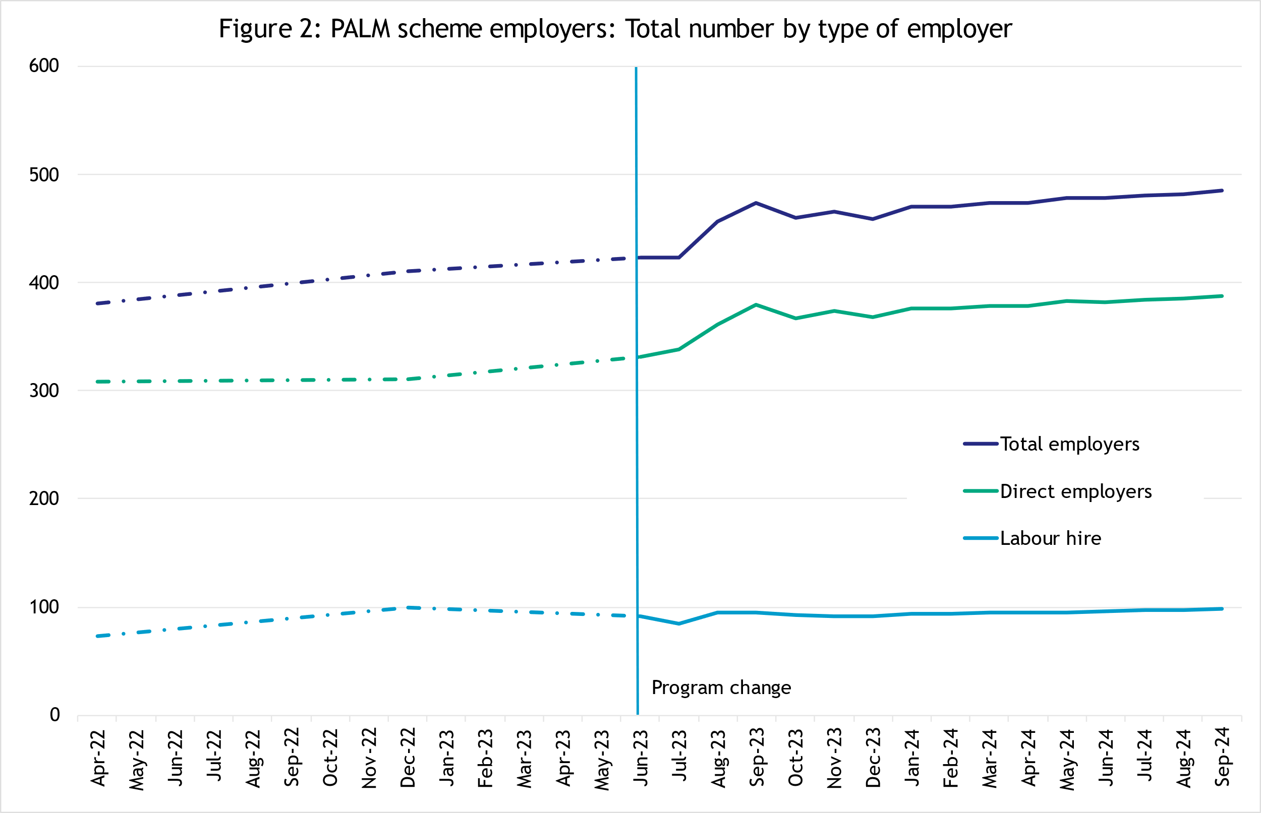

## Appendix A: Detailed PALM scheme worker trends

### PALM scheme worker trends by industry

The PALM scheme has become increasingly diversified, with employers from a broader range of industries entering the scheme, offering Pacific island and Timor-Leste workers more choice.

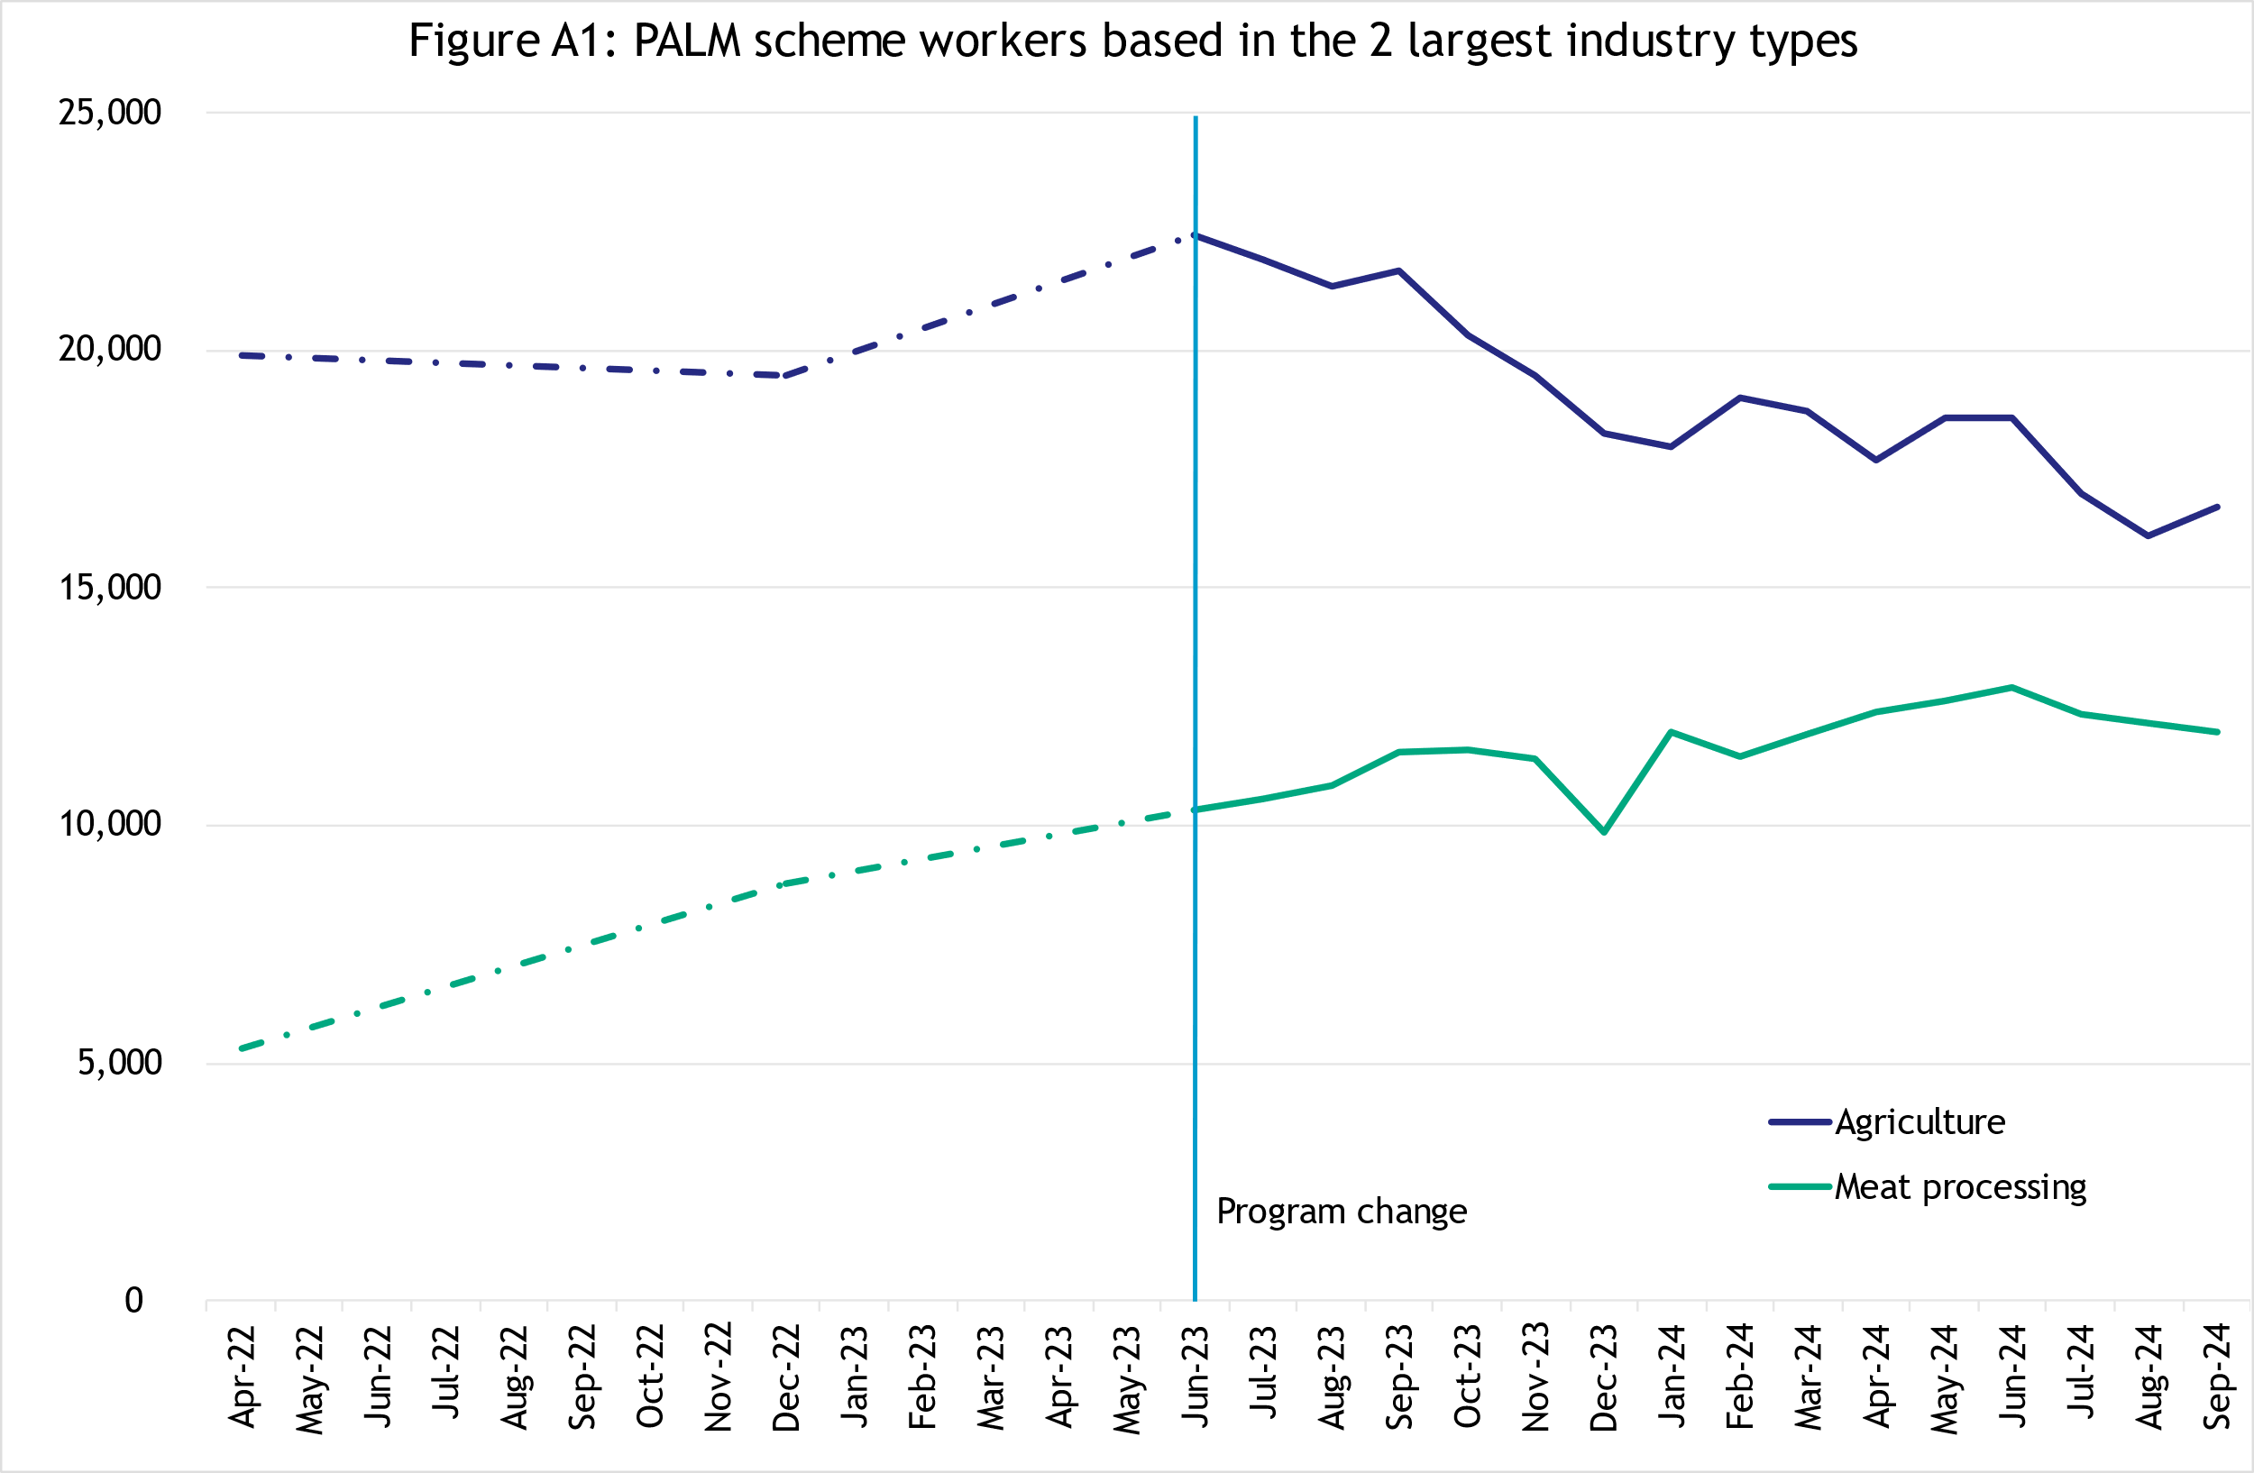

*In September 2024, there were:*

* 16,705 workers in Agriculture
* down 16% since April 2022
* down 23% in the 12 months to September 2024
* 84% are short-term
* 16% are long-term
* 11,980 workers in Meat processing
* up 126% since April 2022
* up 4% in the 12 months to September 2024
* 2% are short-term
* 98% are long-term
* 720 workers in accommodation
* up 39% since April 2022
* up 15% in the 12 months to September 2024
* 18% are short-term
* 82% are long-term
* 1,235 workers in Health care and social assistance
* up 531% since April 2022
* up 43% in the 12 months to September 2024
* 100% are long-term
* 590 workers in Other industries
* up 148% since April 2022
* up 460% in the 12 months to September 2024
* 7% are short-term
* 93% are long-term

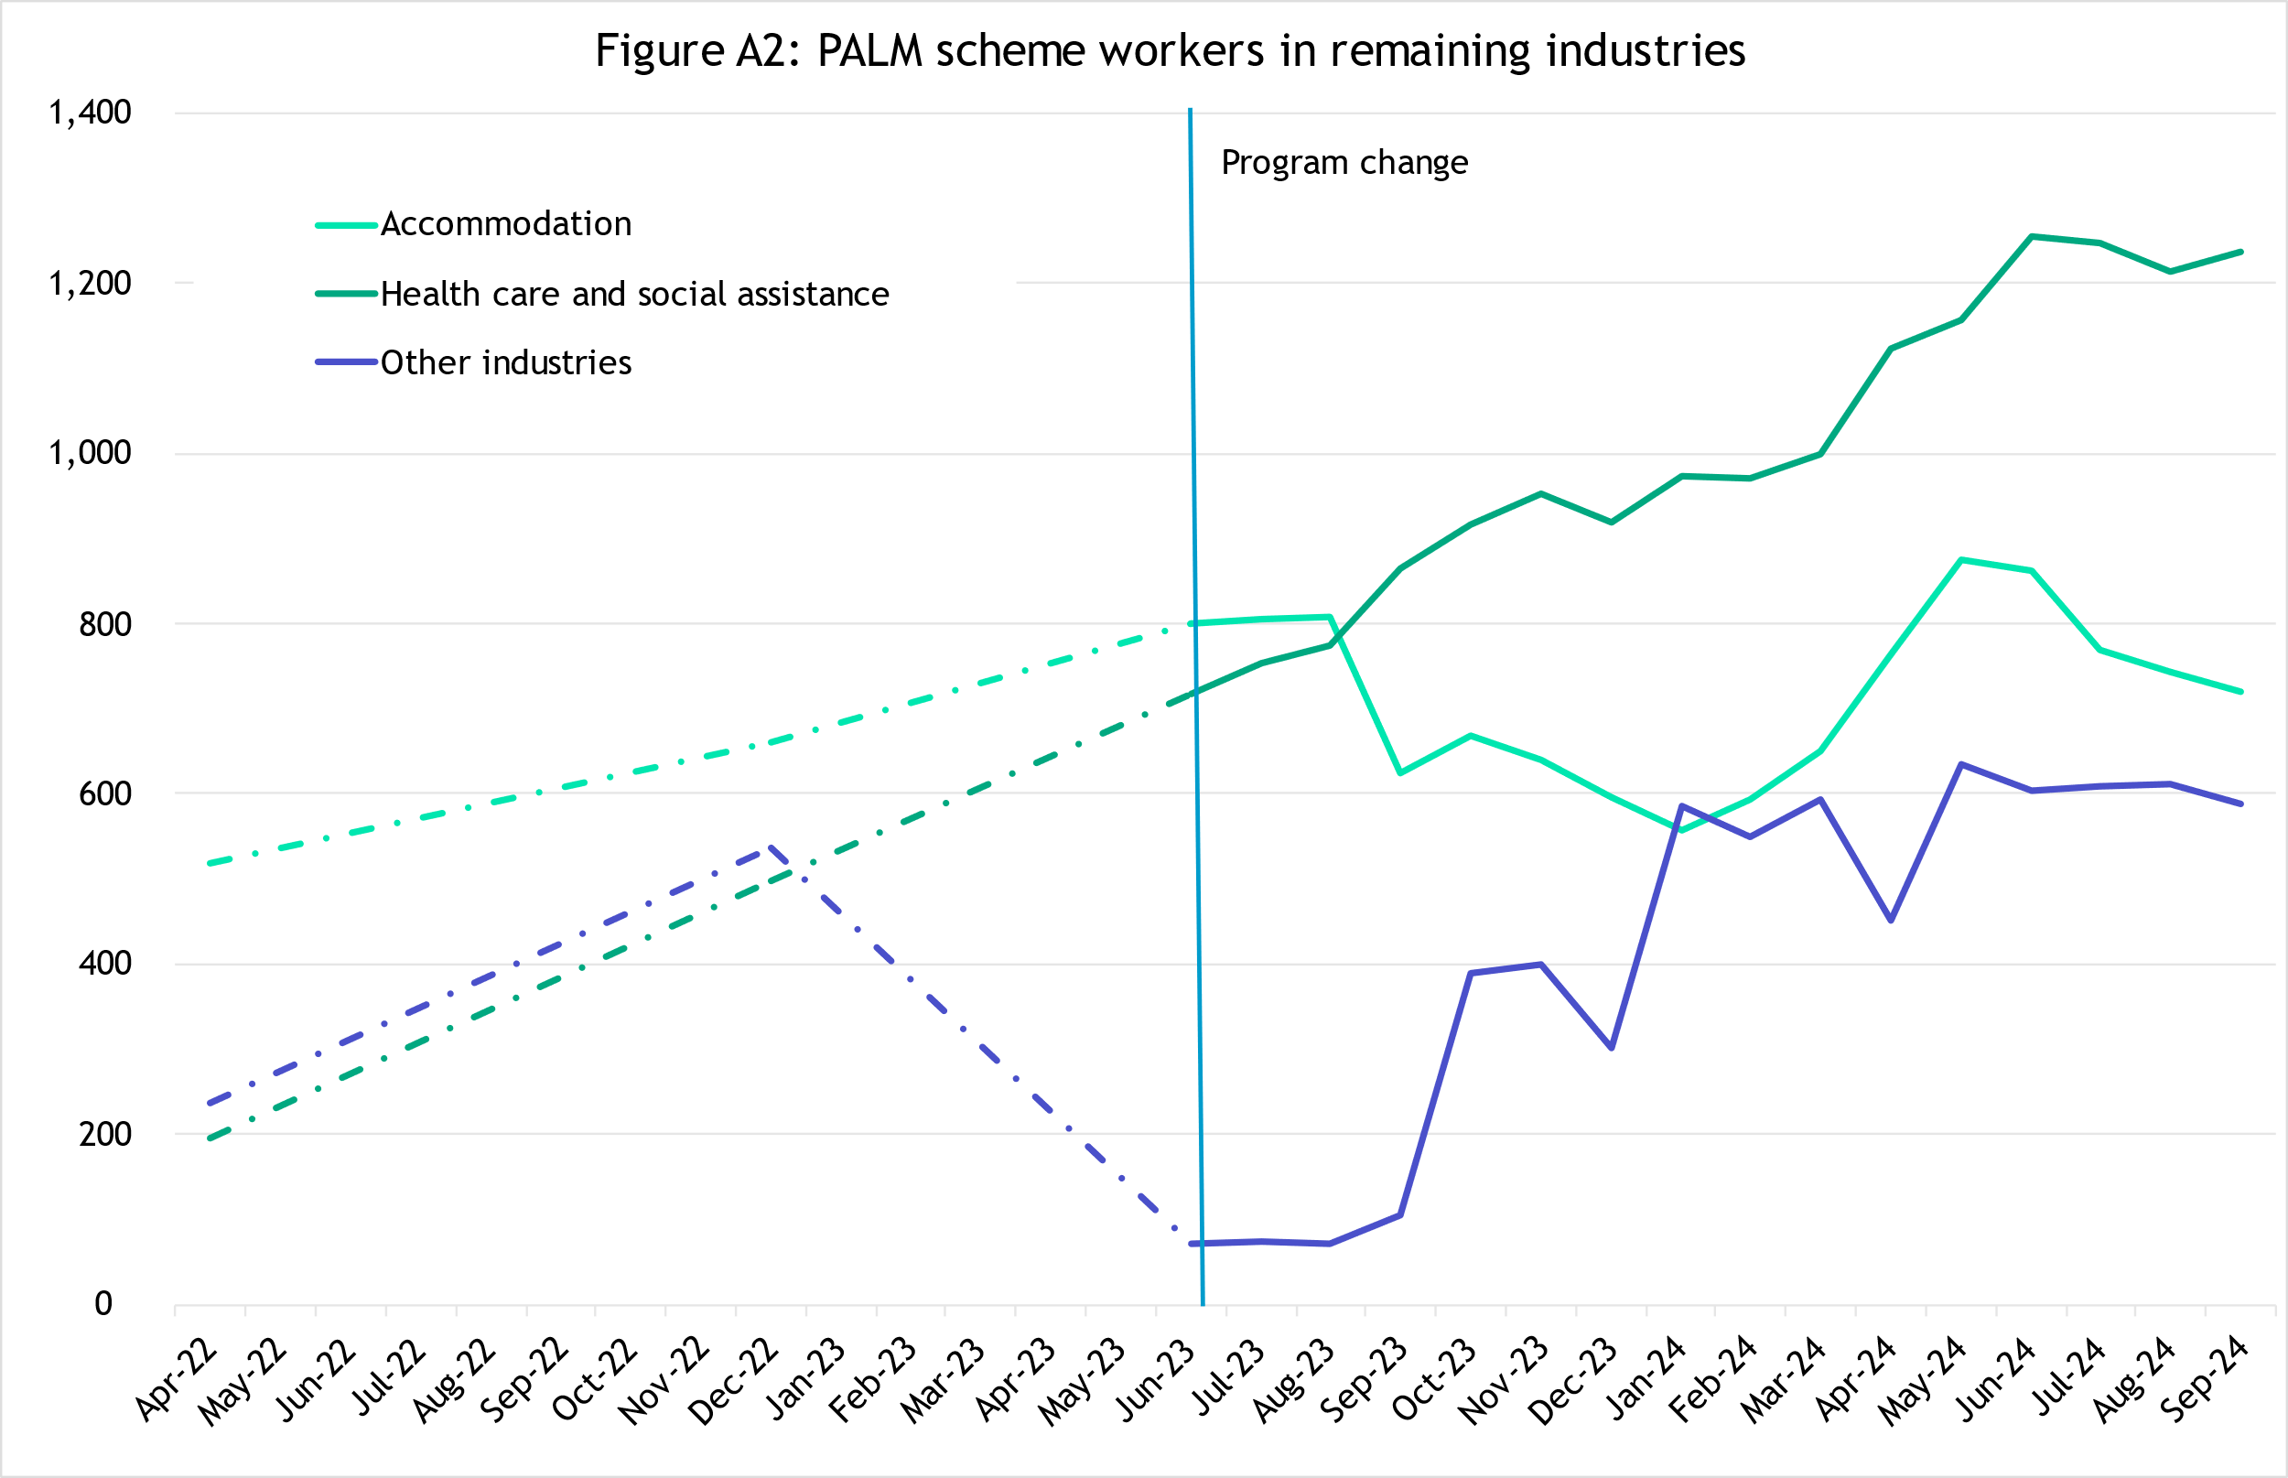

### Worker trends by country of origin

##### Fiji

In September 2024, there were:

* 6,070 workers
* up 273% since April 2022
* down 7% in the 12 months to September 2024
* 80% of Fijian PALM scheme workers are in the long-term stream.

##### Kiribati

In September 2024, there were:

* 1,555 workers
* up 97% since April 2022
* up 13% in the 12 months to September 2024
* 74% of Kiribati PALM scheme workers are in the long-term stream.

##### Nauru

In September 2024, there were:

* 35 workers
* up 260% since April 2022
* up 500% in the 12 months to September 2024
* 100% of Nauru PALM scheme workers are in the long-term stream.

##### Papua New Guinea

In September 2024, there were:

* 2,005 workers
* up 419% since April 2022
* up 17% in the 12 months to September 2024
* 84% of Papua New Guinea PALM scheme workers are in the long-term stream.

##### Samoa

In September 2024, there were:

* 2,745 workers
* down 33% since April 2022
* down 29% in the 12 months to September 2024
* 58% of Samoan PALM scheme workers are in the long-term stream.

##### Solomon Islands

In September 2024, there were:

* 4,870 workers
* up 67% since April 2022
* down 2% in the 12 months to September 2024
* 77% of Solomon Islands PALM scheme workers are in the long-term stream.

##### Timor-Leste

In September 2024, there were:

* 4,140 workers
* up 141% since April 2022
* up 8% in the 12 months to September 2024
* 66% of Timor-Leste PALM scheme workers are in the short-term stream.

##### Tonga

In September 2024, there were:

* 3,350 workers
* down 44% since April 2022
* down 30% in the 12 months to September 2024
* 66% of Tongan PALM scheme workers are in the short-term stream.

##### Tuvalu

In September 2024, there were:

* 300 workers
* up 2,890% since April 2022
* up 135% in the 12 months to September 2024
* 100% of Tuvalu PALM scheme workers are in the long-term stream.

##### Vanuatu

In September 2024, there were:

* 6,155 workers
* down 28% since April 2022
* down 19% in the 12 months to September 2024
* 84% of Vanuatu PALM scheme workers are in the short-term stream.

### Worker trends by state/territory

##### New South Wales

In September 2024, there were:

• 5,995 workers

* up 197% since April 2022
* up 29% in the 12 months to September 2024
* 70% of New South Wales PALM workers are in the long-term stream.70% of New South Wales PALM scheme workers are in the long-term stream.

##### Victoria

In September 2024, there were:

* 5,680 workers
* up 140% since April 2022
* down 8% in the 12 months to September 2024
* 64% of Victorian PALM scheme workers are in the long-term stream.

##### Queensland

In September 2024, there were:

* 11,170 workers
* up 6% since April 2022
* down 16% in the 12 months to September 2024
* 51% of Queensland PALM scheme workers are in the long-term stream.

##### South Australia

In September 2024, there were:

* 2,830 workers
* up 114% since April 2022
* up 81% in the 12 months to September 2024
* 67% of South Australian PALM scheme workers are in the short-term stream.

##### Western Australia

In September 2024, there were:

* 2,805 workers
* up 60% since April 2022
* up 6% in the 12 months to September 2024
* 53% of Western Australian PALM scheme workers are in the long-term stream.

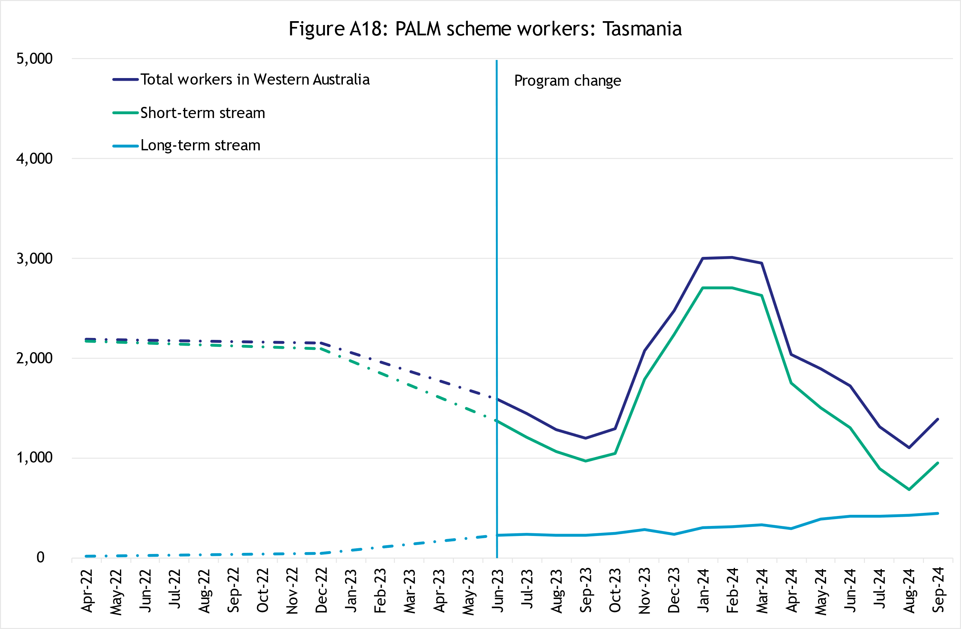Tasmania

In September 2024, there were:

* 1,390 workers
* down 43% since April 2022
* up 16% in the 12 months to September 2024
* 68% of Tasmanian PALM scheme workers are in the short-term stream.

##### Northern Territory

In September 2024, there were:

* 745 workers
* up 38% since April 2022
* up 23% in the 12 months to September 2024
* 53% of Northern Territory PALM scheme workers are in the short-term stream.

##### Australian Capital Territory

In September 2024, there were:

* 30 workers
* up 383% since April 2022
* down 9% in the 12 months to September 2024
* 100% of Australian Capital Territory PALM scheme workers are in the long-term stream.

## Explanatory notes

### Introduction

The PALM scheme allows Australian businesses to hire workers from 9 Pacific island countries and Timor-Leste when there are not enough local workers available. Businesses who meet the eligibility criteria can access workers in the short-term stream (up to 9 months) and/or in the long-term stream (between one and 4 years).

PALM scheme employers in the agriculture sector and select agriculture-related food product manufacturing sectors can be based anywhere in Australia. All other sectors must be based in a regional or rural location.

For more information, refer to the PALM scheme website: [www.palmscheme.gov.au](http://www.palmscheme.gov.au).

### Data sources

PALM scheme worker data is a combination of data from the Department of Employment and Workplace Relations (DEWR) IT systems and visa data sourced from the Department of Home Affairs. DEWR administrative data is stored in a live system and reliant on information entered by labour sending units located in each of the partner countries and PALM scheme employers.

### Data confidentiality

To protect individuals’ privacy, all cells including any totals and subtotals have been rounded to the nearest 5; values from 1 to 7 are rounded to 5. Zero cells are actual zeros. This may result in non-additivity for some totals. Caution should be taken in recalculating totals from rounded data, as this may compound the effects of rounding.

### Glossary

*PALM scheme worker:*

Citizen of a PALM scheme participating country who is issued an approved offer of employment in accordance with the PALM scheme deed and who is granted a PALM stream - temporary work (international relations) visa (subclass 403) or who holds a pandemic event (subclass 408) visa.

* Some PALM scheme workers continue to hold a Pandemic event (subclass 408) visa. This visa type is no longer being granted for the purposes of participating in the PALM scheme. Existing Pandemic event (subclass 408) visas will phase out by the end of 2024.

PALM scheme worker data is derived by combining data from DEWR's IT systems and visa data sourced from the Department of Home Affairs. DEWR data is matched against visa data for comprehensive validation and used to construct valid and accurate counts for PALM scheme workers who are identified in visa data as onshore. Offshore visa holders are excluded from the counts.

*PALM scheme employer:*

An entity contracted by DEWR under the PALM scheme deed. Employers can be direct employers (arranges the placement of PALM scheme workers it employs with its own business) or labour hire organisations arranging the placement of PALM scheme workers it employs with host organisations using a labour hire arrangement.

*Country of origin:*

PALM scheme participating country that a PALM scheme worker is from. PALM scheme participating countries are Fiji, Kiribati, Nauru, Papua New Guinea, Samoa, Solomon Islands, Timor-Leste, Tonga, Tuvalu and Vanuatu.

‘Unknown’ country of origin is where country of origin cannot be determined for a PALM scheme worker due to incomplete data.

*Stream:*

Length of placement of employed PALM scheme workers. This is either 'short-term' or 'long-term':

* *Short-term*: a placement with short-term PALM scheme workers who hold the relevant visa and are employed in a contract of work for up to 9 months.
* *Long-term*: a placement with long-term PALM scheme workers who hold the relevant visa and are employed in a contract of work for up to 4 years (non-seasonal).

*Industry:*

Where possible, industries are classified to the Australian Bureau of Statistics Australian and New Zealand Standard Industrial Classification (ANZSIC). An individual business entity is assigned to an industry based on its predominant activity.

Due to gaps in data sources, a best-fit approach has been used to identify industry. ‘Role descriptions’ (which are job or occupation descriptions) may be used to help identify an accurate industry fit.

PALM scheme data is reported to 5 key industry groups: Agriculture, Meat Processing, Accommodation, Health Care and Social Assistance, and Other industries.

* *Agriculture:*

Reflects workers in ANZSIC Division A: Agriculture, Forestry and Fishing.

* *Meat Processing:*

Includes Meat and Meat Product Manufacturing (a subset of the ANZSIC Division C: Manufacturing)

* *Accommodation:*  
  ANZSIC Division H: Accommodation and Food Services.
* *Health care and social assistance*:  
  ANZSIC Division Q: Health Care and Social Assistance. Includes aged, disability and other health care services, including residential care.
* *Other Industries:*

Includes all remaining industries, that are not otherwise classified to the industries above. Note that a small number of workers in manufacturing in non-meat processing (such as grain and cereal manufacturing, or textile or clothing manufacturing) are included in Other industries. Any workers in Retail are included in Other industries.

## Citation

Any publications or reports using the data reported by DEWR must cite DEWR as the source. Where this data has been used for further analysis and interpretation, DEWR requests the inclusion of the following statement in the published report:

*“The views expressed in this report are those of the authors and do not necessarily represent those of DEWR."*

## Contact

For any inquiries, please contact:

* for general PALM scheme enquiries: ([PALM@dewr.gov.au](mailto:PALM@dewr.gov.au))
* for PALM scheme data enquiries: ([pacificlabourdata@dewr.gov.au](mailto:pacificlabourdata@dewr.gov.au)).