# Pacific Australia Labour Mobility scheme quarterly update

# Data current up to 31 December 2024

# Published: 7 March 2025

## Key findings

Pacific Australia Labour Mobility (PALM) scheme worker counts are a measure of the number of workers from participating PALM scheme countries holding a valid visa who are currently onshore in Australia. Worker participation will vary from month to month reflecting a range of factors, including:

* the cyclical nature of the program and worker visa conditions (9 months for the short-term stream and up to 4 years for the long-term stream)
* changing workforce demand stemming from growing cycles for different crops in different regions, and
* workers returning home for holidays or other commitments.

In December each year, many PALM scheme employers close down for the holiday period and a high number of workers in the long-term stream return home for holidays. The majority of these workers return to Australia to resume work in the PALM scheme in January or February. PALM scheme worker counts are not adjusted to account for seasonal events so some caution needs to be applied to the findings in this report.

**Worker counts — year to December 2024**

Over the 12 months to December 2024:

* the worker count decreased by 9%.
  + short-term worker counts declined by 16% over the year
  + long-term worker counts declined by 1% over the year.
* by industry, Agriculture and Meat processing declined over the year in contrast to other industries which increased.
  + Agriculture declined by 16% (2,985 workers) since December 2023. This is largely attributed to the departure of 408 Pandemic event visa holders, who predominantly work in agriculture.
  + Meat processing declined by 1% over the year. Note that over 97% of workers in this industry are in the long-term stream. A slightly higher proportion of these workers temporarily departed Australia in December 2024 compared with December 2023.
  + Other industries saw an increase: Accommodation increased by 4%; Health care and Social Assistance increased by 28%; and Other industries increased by 50%.
* by country, between December 2023 and December 2024:
  + worker counts increased for: Papua New Guinea, Tuvalu, Timor-Leste, and a significant increase for Nauru.
  + worker counts decreased for: Fiji, Kiribati, Samoa, Solomon Islands, Tonga and Vanuatu.

**PALM scheme visa analysis**

Until recently, PALM scheme workers could access two types of visas:

* PALM stream temporary work (international relations) visa (subclass 403); or
* the temporary COVID-19 Pandemic event (subclass 408 visa) visa (now closed).

During the COVID-19 pandemic, the PALM scheme was heavily relied upon as there were limited alternate sources of temporary labour. Short-term PALM scheme workers could apply for the Pandemic even subclass 408 visa to stay in Australia longer, providing a reliable workforce during the pandemic. Growth rates in the PALM scheme have moderated as the subclass 408 visa has concluded, particularly from around March 2023.

The rate of loss of 408 visa holders was greater than the entry rate of PALM 403-visa holders. In June 2023, 14% of PALM scheme workers (or 4,830 people) held a 408 visa. By December 2024, this had reduced to 0.2% (65 workers). 408-visa holders were overwhelmingly employed in agriculture.

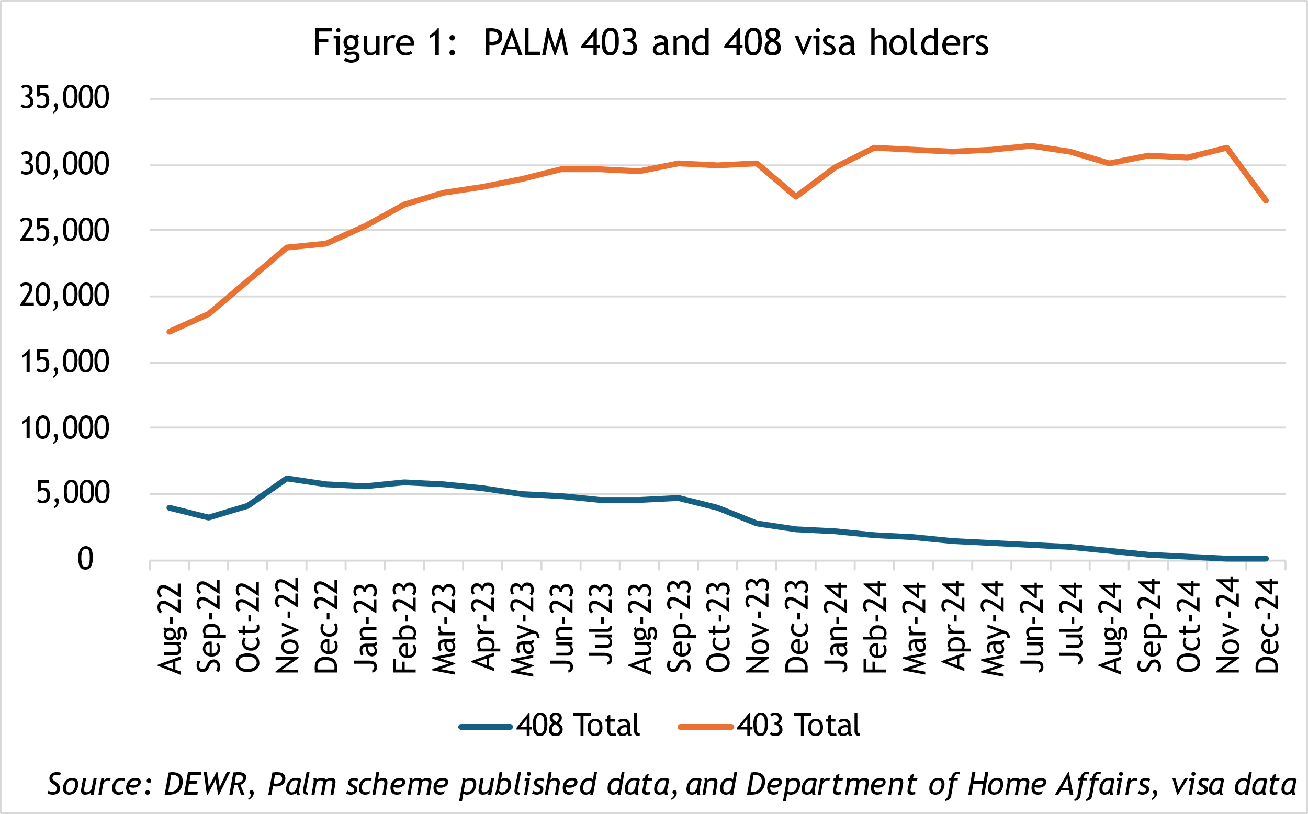

On the other hand, the number of onshore 403 visa holders rose rapidly between April 2022 and early 2024 with numbers relatively stable in 2024 (excluding the expected December dips in 2023 and 2024 as workers returned home temporarily). See above chart.

* The number of short-term stream onshore 403 visa holders has been relatively steady since the new PALM scheme deed and guidelines were introduced in June 2023, despite some month-to-month volatility.
* The number of long-term stream onshore 403 visa holders rose substantially to mid-2024, before reducing slightly in the second half of the year.

**PALM scheme employers**

The number of PALM scheme employers has continued to grow since the new PALM scheme deed and guidelines were introduced in June 2023.

* 103 new employers have joined the scheme since June 2023, bringing the total number of employers to 493 in December 2024, a record high since the commencement of the PALM scheme (and predecessor schemes).

There are a range of factors which impact demand for PALM scheme workers, including:

* climate change, natural disasters and local severe weather events impacting harvest yield and timing
* drops in some global commodity prices
* the number of Working Holiday Makers increasing over the last three years to reach 206,187 in December 2024, exceeding pre-covid levels
* a drop in demand for agriculture workers (to 2022-23, latest data available[1]).

# *Data and chart notes:*

All published PALM scheme worker data including any totals and subtotals are rounded to the nearest 5. For more information see the Glossary.

Worker counts are only available for April 2022, December 2022 and from June 2023 onwards. In the charts, the unknown values between April 2022 and December 2022, and December 2022 and June 2023 have been inferred and are represented by the dotted lines. This produces unnaturally smooth lines that are not representative of the usual fluctuations expected in the monthly data.

## PALM scheme worker trends

In December 2024, there were:

* 27,260 workers
* 13,315 in the short-term stream
* 13,940 in the long-term stream

The decline in the worker count between November 2023 and December 2023 was 9%, compared with 13% between November and December 2024.

In the 12 months to December 2024, total workers were down by 9%:

* Total long-term stream was down by 1%
* Total short-term stream was down by 16%

## PALM scheme employer trends

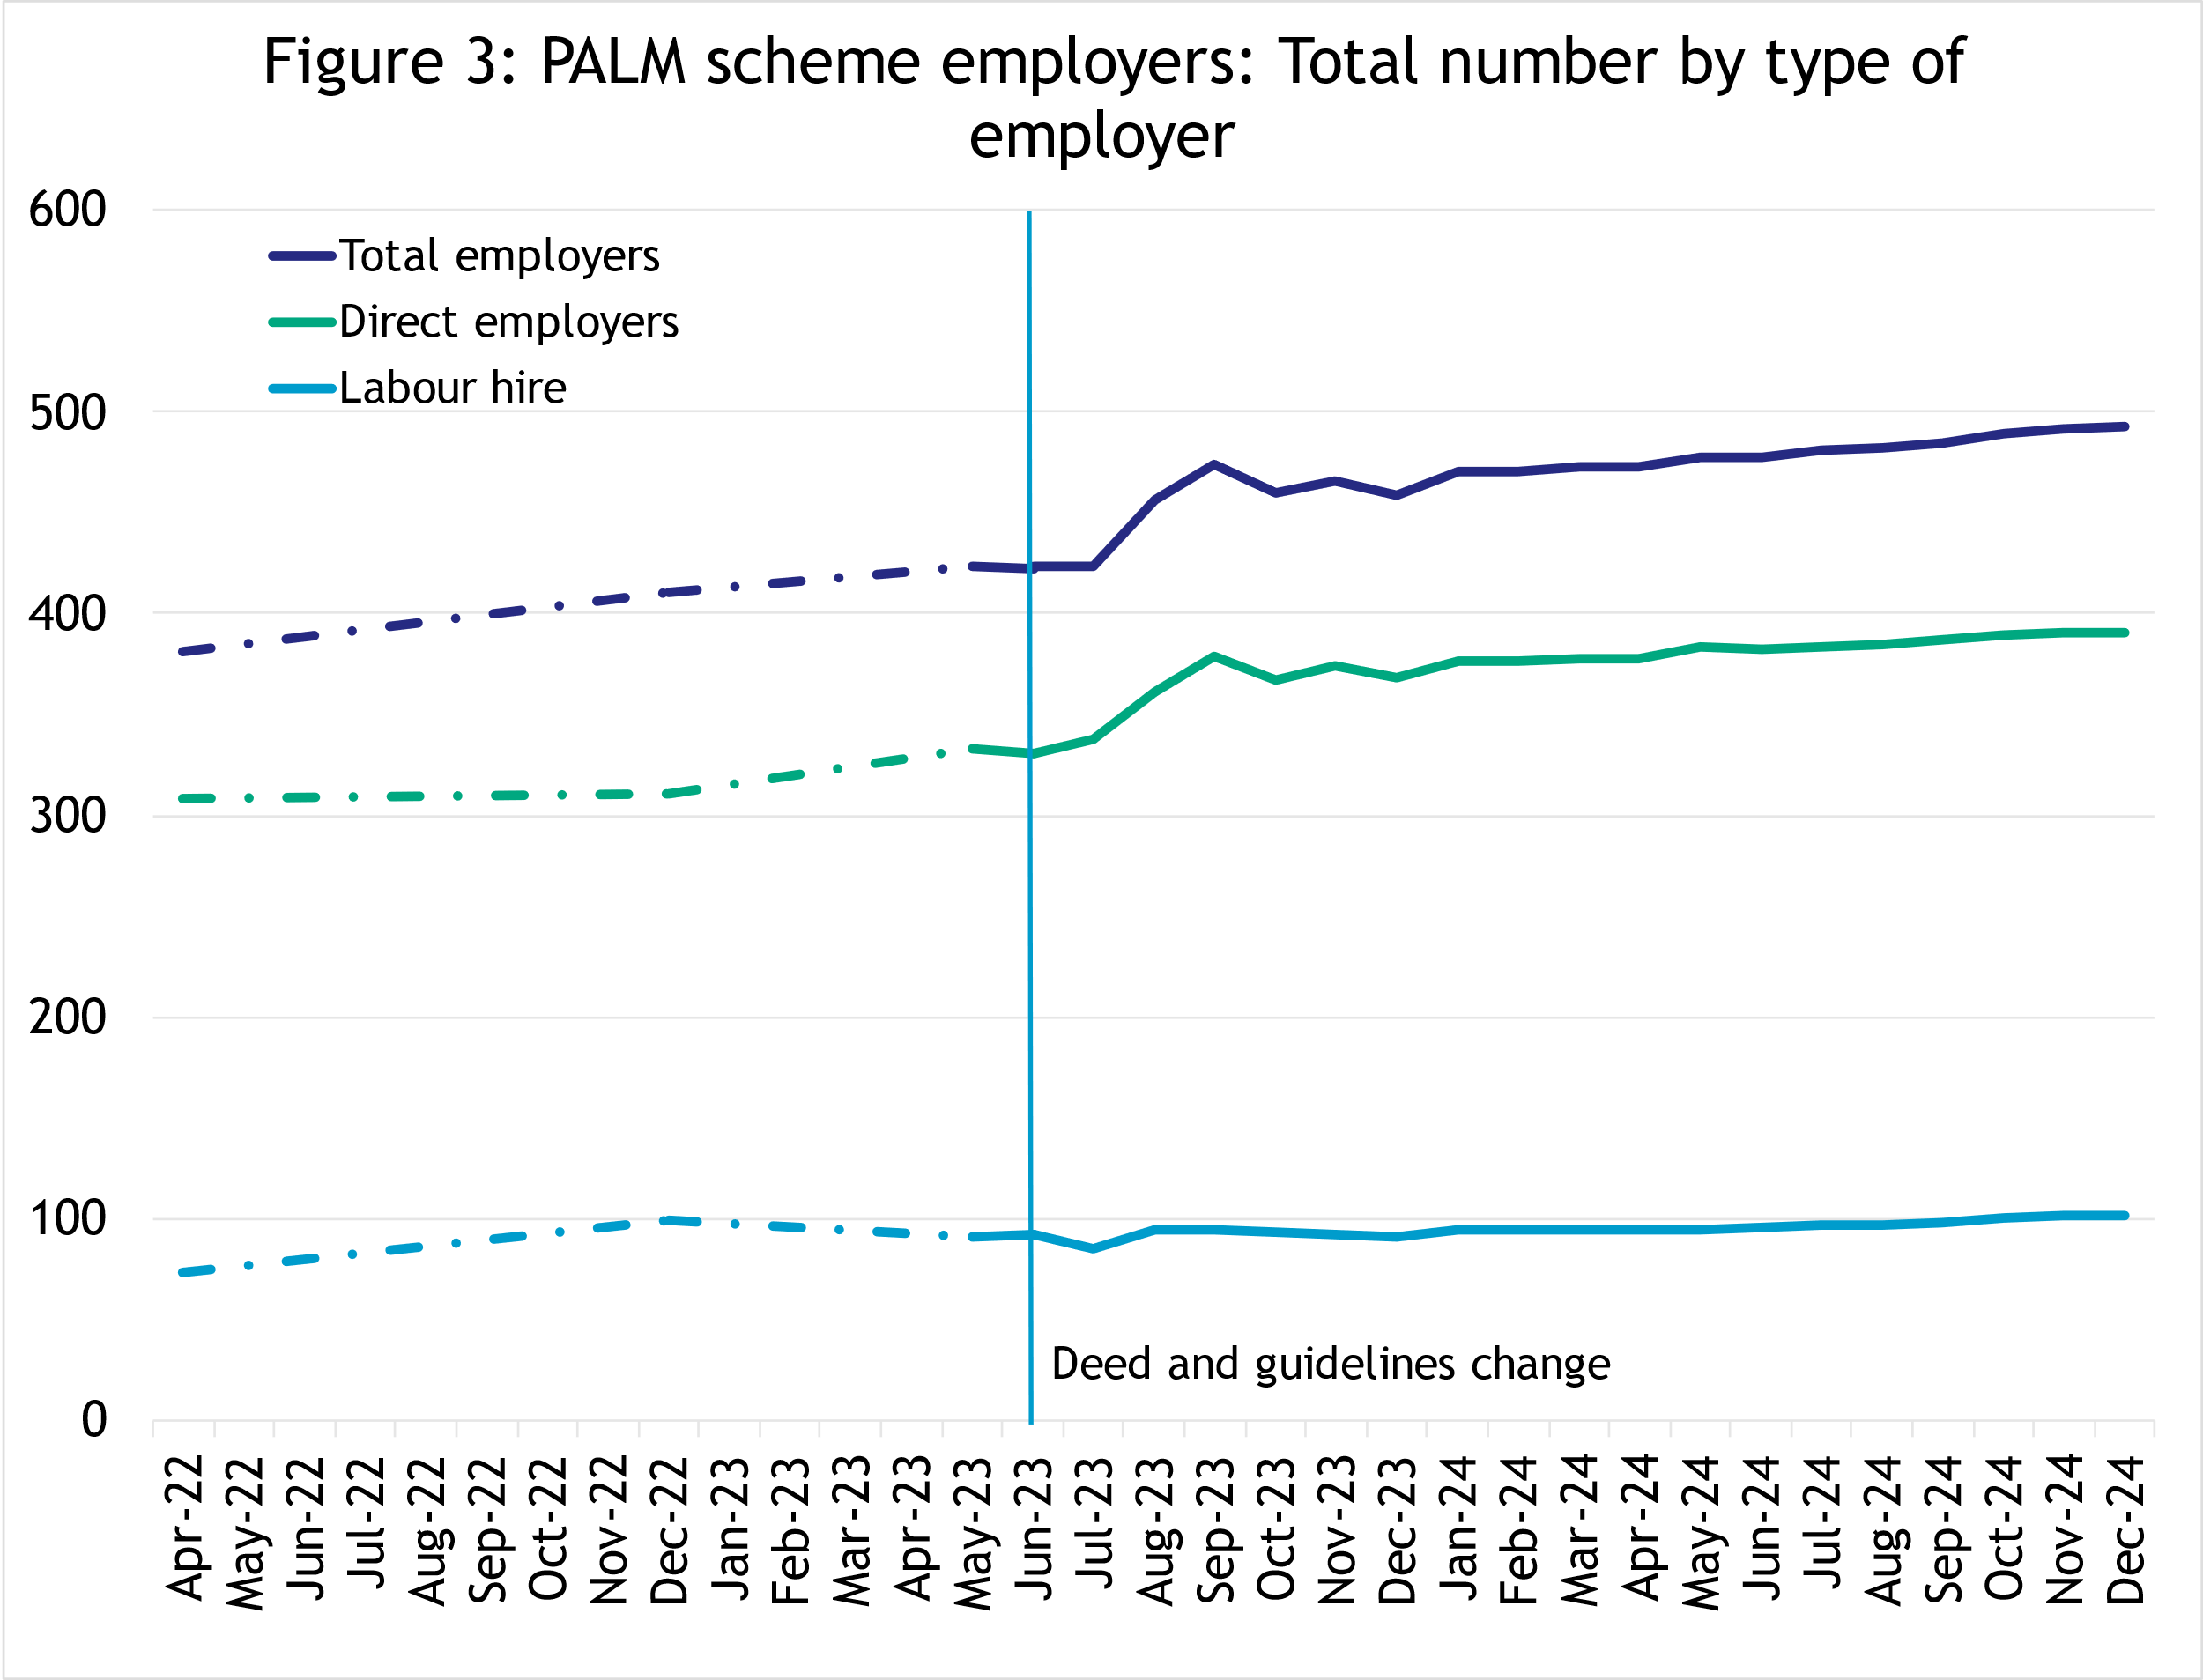

In December 2024, there were:

* 493 employers
* 391 were direct employers  
  (Up 6% in the 12 months to December 2024)
* 102 were labour hire employers  
  (Up 12% in the 12 months to December 2024)

## Appendix A: detailed PALM scheme worker trends

### PALM scheme worker trends by industry

The PALM scheme has become increasingly diversified, with employers from a broader range of industries entering the scheme, offering Pacific Island and Timor-Leste workers more choice.

In December 2024, there were:

* 15,265 workers in Agriculture
* down 23% since April 2022
* down 16% in the 12 months to December 2024
* 85% are short-term
* 16% are long-term.
* 9,745 workers in Meat processing
* up 84% since April 2022
* down 1% in the 12 months to December 2024
* 3% are short-term
* 97% are long-term.
* 620 workers in accommodation
* up 19% since April 2022
* up 4% in the 12 months to December 2024
* 12% are short-term
* 88% are long-term.
* 1,175 workers in Health care and Social Assistance
* up 498% since April 2022
* up 28% in the 12 months to December 2024
* 100% are long-term.
* 455 workers in Other industries
* up 92% since April 2022
* up 50% in the 12 months to December 2024
* 9% are short-term
* 91% are long-term.

### PALM scheme worker trends by country of origin

##### Fiji

In December 2024, there were:

* 4,770 workers
* up 193% since April 2022
* down 12% in the 12 months to December 2024
* 85% of Fijian PALM scheme workers are in the long-term stream.

##### Kiribati

In December 2024, there were:

* 1,365 workers
* up 74% since April 2022
* down 4% in the 12 months to December 2024
* 76% of Kiribati PALM scheme workers are in the long-term stream.

##### Nauru

In December 2024, there were:

* 50 workers
* up 380% since April 2022
* up 300% in the 12 months to December 2024
* 100% of Nauru PALM scheme workers are in the long-term stream.

In December 2024, total workers from Nauru also rose significantly by 120% compared to the last quarter.

##### Papua New Guinea

In December 2024, there were:

* 1,600 workers
* up 313% since April 2022
* up 13% in the 12 months to December 2024
* 83% of Papua New Guinea PALM scheme workers are in the long-term stream.

##### Samoa

In December 2024, there were:

* 2,510 workers
* down 39% since April 2022
* down 22% in the 12 months to December 2024
* 54% of Samoan PALM scheme workers are in the short-term stream.

##### Solomon Islands

In December 2024, there were:

* 3,845 workers
* up 31% since April 2022
* down 3% in the 12 months to December 2024
* 77% of Solomon Islands PALM scheme workers are in the long-term stream.

##### Timor-Leste

In December 2024, there were:

* 4,425 workers
* up 158% since April 2022
* up 15% in the 12 months to December 2024
* 72% of Timor-Leste PALM scheme workers are in the short-term stream.

##### Tonga

In December 2024, there were:

* 2,725 workers
* down 55% since April 2022
* down 24% in the 12 months to December 2024
* 67% of Tongan PALM scheme workers are in the short-term stream.

##### Tuvalu

In December 2024, there were:

* 275 workers
* up 2,630% since April 2022
* up 48% in the 12 months to December 2024
* 100% of Tuvalu PALM scheme workers are in the long-term stream.

Vanuatu

In December 2024, there were:

* 5,705 workers
* down 34% since April 2022
* down 16% in the 12 months to December 2024
* 84% of Vanuatu PALM scheme workers are in the short-term stream.

### PALM scheme worker trends by state/territory

##### New South Wales

In December 2024, there were:

• 5,130 workers

* up 154% since April 2022
* up 15% in the 12 months to December 2024
* 73% of New South Wales PALM scheme workers are in the long-term stream.

Victoria

In December 2024, there were:

* 5,105 workers
* up 116% since April 2022
* down 15% in the 12 months to December 2024
* 63% of Victorian PALM scheme workers are in the long-term stream.

##### Queensland

In December 2024, there were:

* 8,475 workers
* down 20% since April 2022
* down 12% in the 12 months to December 2024
* 51% of Queensland PALM scheme workers are in the long-term stream.

##### South Australia

In December 2024, there were:

* 2,080 workers
* up 57% since April 2022
* down 4% in the 12 months to December 2024
* 59% of South Australian PALM scheme workers are in the short-term stream.

##### Western Australia

In December 2024, there were:

* 2,425 workers
* up 39% since April 2022
* up 3% in the 12 months to December 2024
* 52% of Western Australian PALM scheme workers are in the long-term stream.

##### Tasmania

In December 2024, there were:

* 3,105 workers
* up 42% since April 2022
* up 25% in the 12 months to December 2024
* 87% of Tasmanian PALM scheme workers are in the short-term stream.

##### Northern Territory

In December 2024, there were:

* 845 workers
* up 57% since April 2022
* up 67% in the 12 months to December 2024
* 65% of Northern Territory PALM scheme workers are in the short-term stream.

##### Australian Capital Territory

In December 2024, there were:

* 25 workers
* up 317% since April 2022
* down 17% in the 12 months to December 2024
* 100% of Australian Capital Territory PALM scheme workers are in the long-term stream.

## Explanatory notes

### Introduction

The PALM scheme allows Australian businesses to hire workers from 9 Pacific Island countries and Timor-Leste when there are not enough local workers available. Businesses who meet the eligibility criteria can access workers in the short-term stream (up to 9 months) and/or in the long-term stream (between one and 4 years).

PALM scheme employers in the agriculture sector and select agriculture-related food product manufacturing sectors can be based anywhere in Australia. All other sectors must be based in a regional or rural location.

For more information, refer to the PALM scheme website: [www.palmscheme.gov.au](http://www.palmscheme.gov.au).

### Data sources

PALM scheme worker data is a combination of data from the Department of Employment and Workplace Relations (DEWR) IT systems and visa data sourced from the Department of Home Affairs. DEWR administrative data is stored in a live system and reliant on information entered by labour sending units located in each of the partner countries and PALM scheme employers.

### Data confidentiality

To protect individuals’ privacy, all cells including any totals and subtotals have been rounded to the nearest 5; values from 1 to 7 are rounded to 5. Zero cells are actual zeros. This may result in non-additivity for some totals. Caution should be taken in recalculating totals from rounded data, as this may compound the effects of rounding.

### Glossary

*PALM scheme worker:*

Citizen of a PALM scheme participating country who is issued an approved offer of employment in accordance with the PALM scheme deed and who is granted a PALM stream - temporary work (international relations) visa (subclass 403) or who holds a pandemic event (subclass 408) visa.

* Some PALM scheme workers continue to hold a Pandemic event (subclass 408) visa. This visa type is no longer being granted for the purposes of participating in the PALM scheme. Existing Pandemic event (subclass 408) visas will phase out completely by the first quarter of 2025.

PALM scheme worker data is derived by combining data from DEWR's IT systems and visa data sourced from the Department of Home Affairs. DEWR data is matched against visa data for comprehensive validation and used to construct valid and accurate counts for PALM scheme workers who are identified in visa data as onshore. Offshore visa holders are excluded from the counts.

*PALM scheme employer:*

An entity contracted by DEWR under the PALM scheme deed. Employers can be direct employers (arranges the placement of PALM scheme workers it employs with its own business) or labour hire organisations arranging the placement of PALM scheme workers it employs with host organisations using a labour hire arrangement.

*Country of origin:*

PALM scheme participating country that a PALM scheme worker is from. PALM scheme participating countries are Fiji, Kiribati, Nauru, Papua New Guinea, Samoa, Solomon Islands, Timor-Leste, Tonga, Tuvalu and Vanuatu.

‘Unknown’ country of origin is where country of origin cannot be determined for a PALM scheme worker due to incomplete data.

*Stream:*

Length of placement of employed PALM scheme workers. This is either 'short-term' or 'long-term':

* *Short-term*: a placement with short-term PALM scheme workers who hold the relevant visa and are employed in a contract of work for up to 9 months.
* *Long-term*: a placement with long-term PALM scheme workers who hold the relevant visa and are employed in a contract of work for up to 4 years (non-seasonal).

*Industry:*

Where possible, industries are classified to the Australian Bureau of Statistics Australian and New Zealand Standard Industrial Classification (ANZSIC). An individual business entity is assigned to an industry based on its predominant activity.

Due to gaps in data sources, a best-fit approach has been used to identify industry. ‘Role descriptions’ (which are job or occupation descriptions) may be used to help identify an accurate industry fit.

PALM scheme data is reported to 5 key industry groups: Agriculture, Meat Processing, Accommodation, Health Care and Social Assistance, and Other industries.

* *Agriculture:*

Reflects workers in ANZSIC Division A: Agriculture, Forestry and Fishing.

* *Meat Processing:*

Includes Meat and Meat Product Manufacturing (a subset of the ANZSIC Division C: Manufacturing)

* *Accommodation:*  
  ANZSIC Division H: Accommodation and Food Services.
* *Health care and social assistance*:  
  ANZSIC Division Q: Health Care and Social Assistance. Includes aged, disability and other health care services, including residential care.
* *Other Industries:*

Includes all remaining industries, that are not otherwise classified to the industries above. Note that a small number of workers in manufacturing in non-meat processing (such as grain and cereal manufacturing, or textile or clothing manufacturing) are included in Other industries. Any workers in Retail are included in Other industries.

## Citation

Any publications or reports using the data reported by DEWR must cite DEWR as the source. Where this data has been used for further analysis and interpretation, DEWR requests the inclusion of the following statement in the published report:

*“The views expressed in this report are those of the authors and do not necessarily represent those of DEWR."*

## Contact

For any inquiries, please contact:

* for general PALM scheme enquiries: ([PALM@dewr.gov.au](mailto:PALM@dewr.gov.au))
* for PALM scheme data enquiries: ([pacificlabourdata@dewr.gov.au](mailto:pacificlabourdata@dewr.gov.au)).

1. Australian Bureau of Agricultural and Resource Economics and Sciences (ABARES), Labour use in Australian horticulture: Analysis of survey results, 2022–23.